Terraform modules

Module is a collection of configuration files in a directory

In simple words

using a script from other dir to the main directory using modules

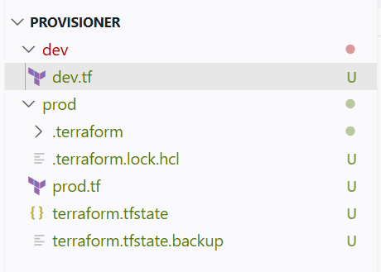

I have given complete script for creating a new instance in another file that is in other directory

And I want that code in my main file script

So I will be using modules for my main script and call using the modules

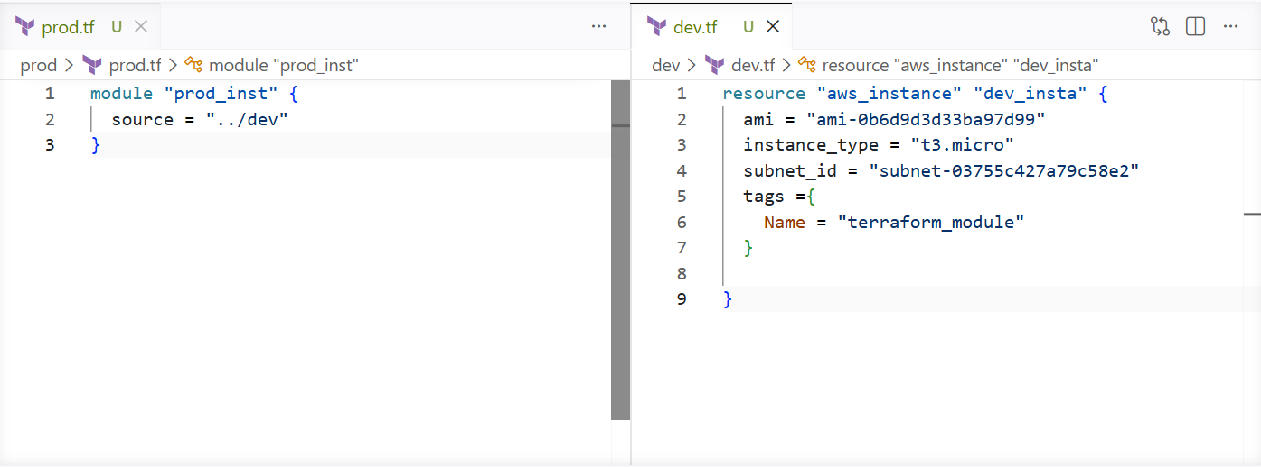

And I can also use variables in other script which is in different dir

A new instance has been created using the modules

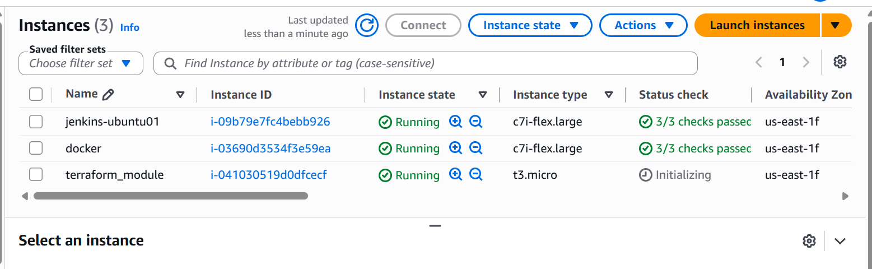

Terraform workspace

Workspace can be used if we have multiple project/ environment using the same configuration

We can create multiple workspaces

To create a new workspace use

Terraform workspace new name

To show the workspace use

Terraform workspace show

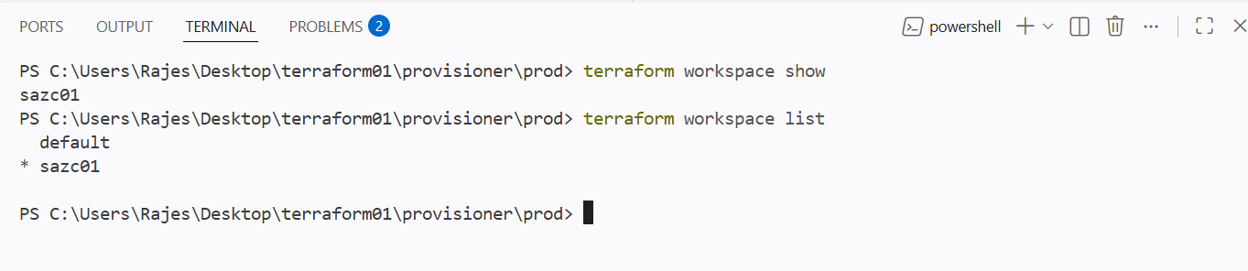

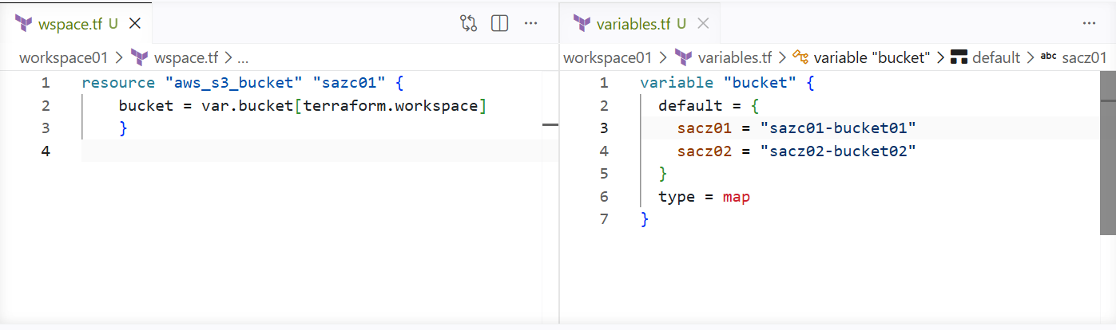

I have given two values for 2 different workspaces and I have switched to my 1st workspace

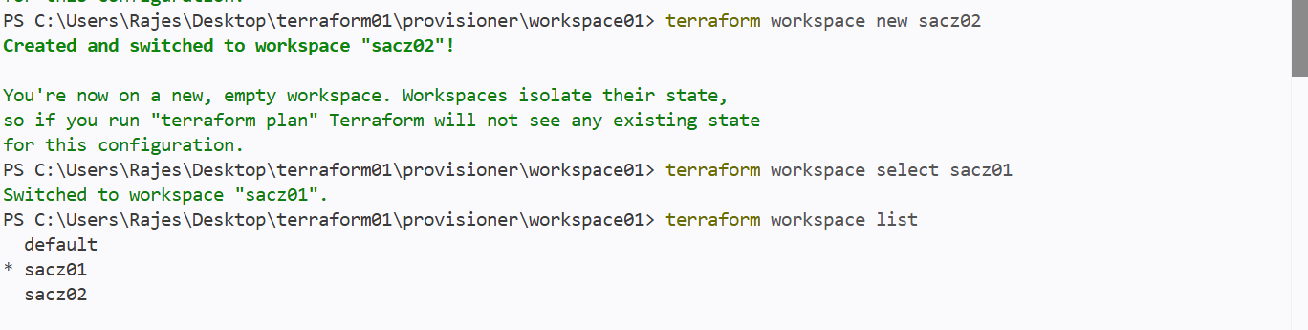

And in the place of var.bucket I have also mentioned that I am working on workpspaces

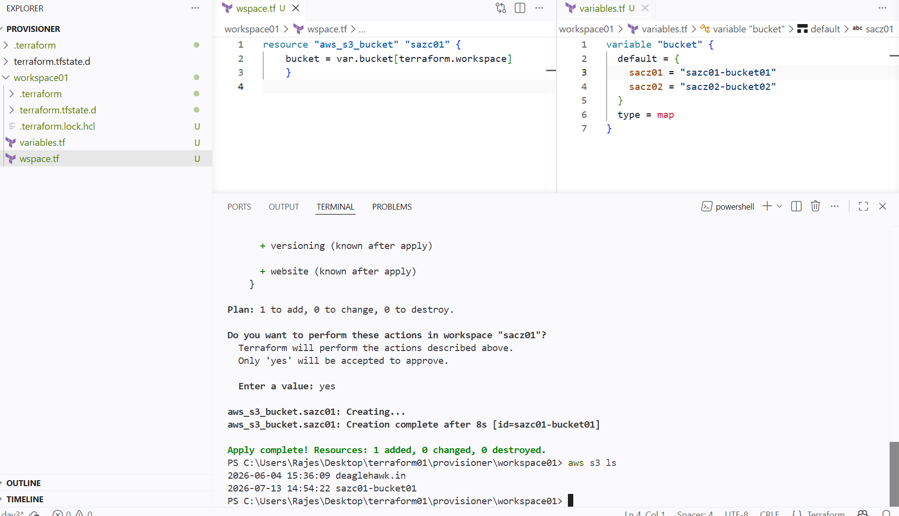

Now I variables file I have given type map because I have multiple names and it should be taken on the name of workspace

Now I have selected the workspace sacz01 and when I perform terraform apply

It should create a new bucket taking the first input of the variable file

And new s3 bucket has been created by the workspace name

Now if I switch to another workspace the state file wont be present

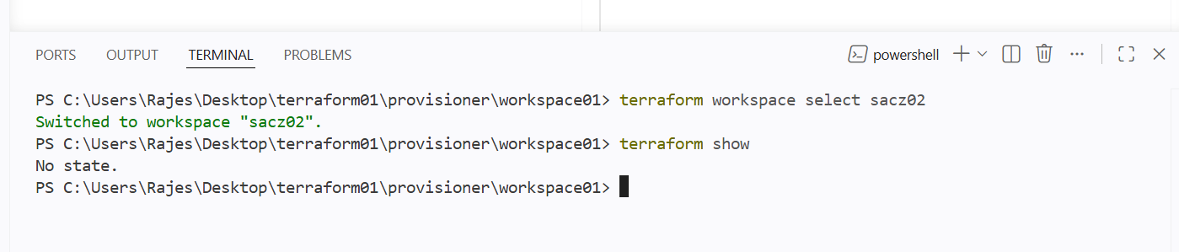

Provision EC2, S3, and VPC using Terraform modules

I will be a resource in different dir and calling that resource to the main file using module

- Ec2
- S3
- vpc

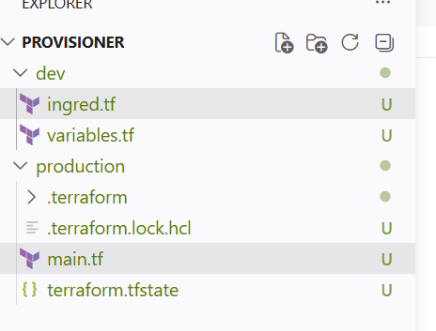

Created a new directory called dev and added resources and variables

Then using this dev script calling from root script as modules

In dev directory I have written a script to create a new instance and new vpc and new bucket and given variables in the same dir

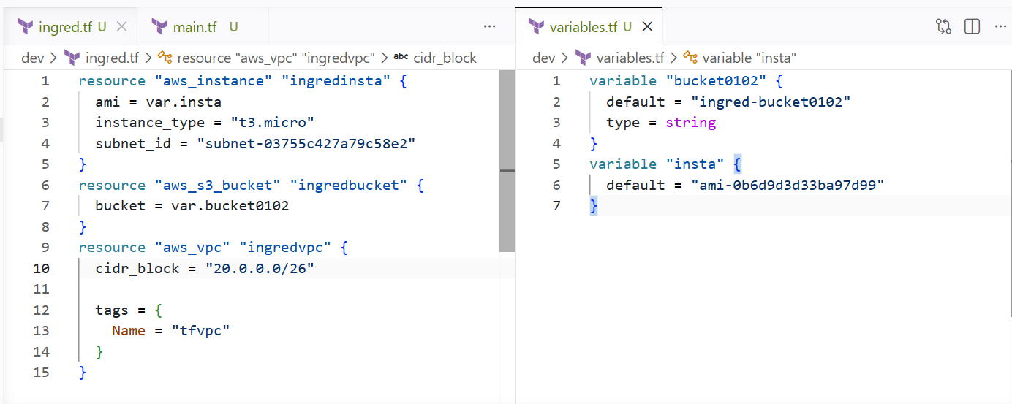

Now calling this script form my main file that is in production directory using modules

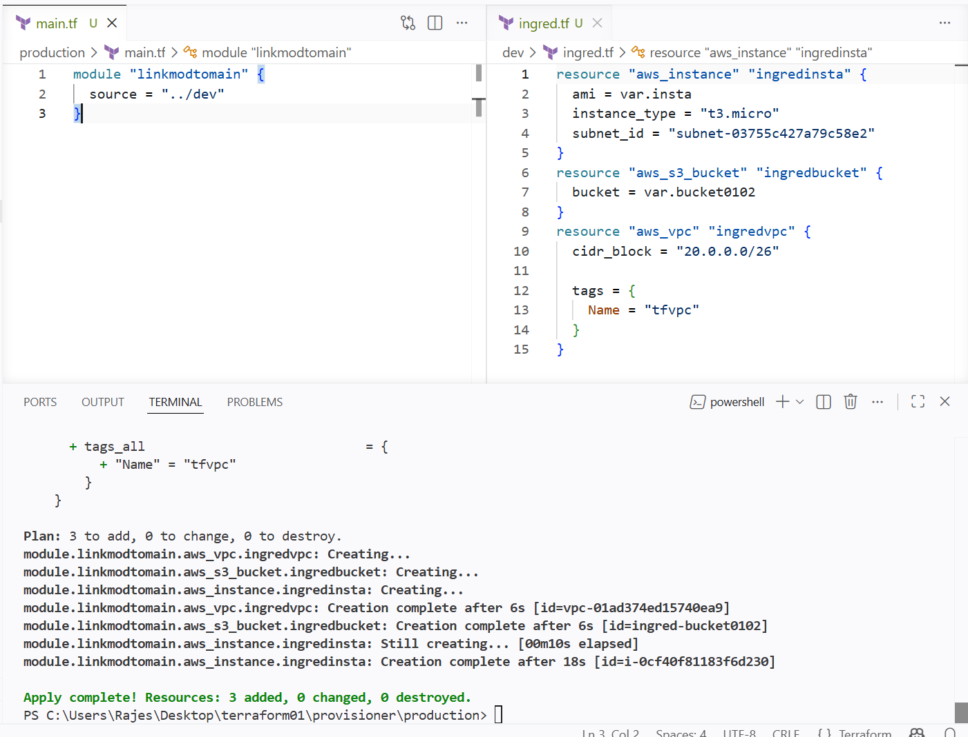

Then terraform apply and we can see new vpc has been created and same goes for s3 and ec2

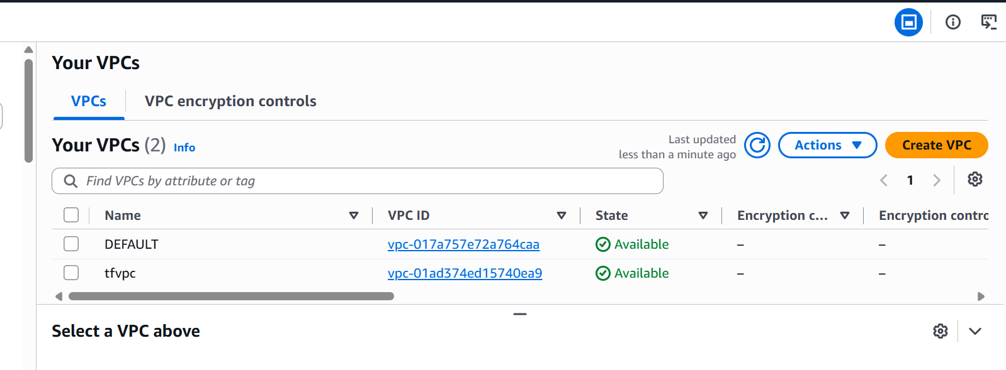

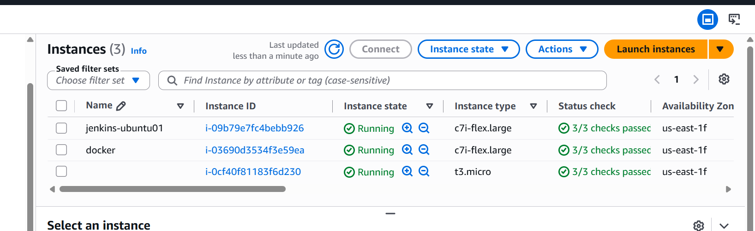

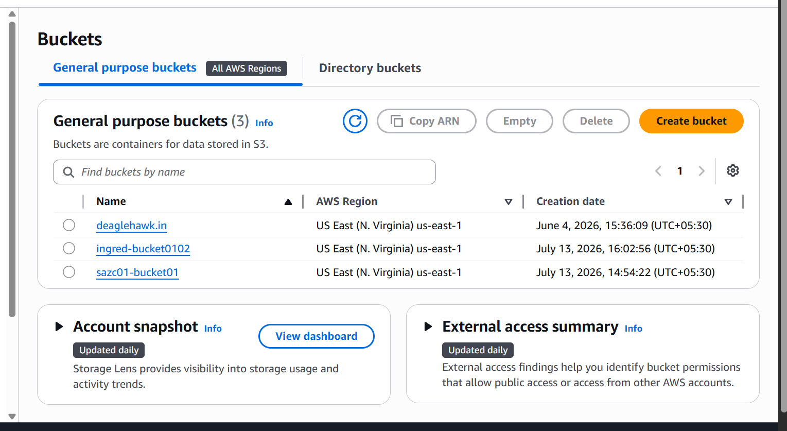

Provision EC2 for 3 different environments (Dev, Staging, and Prod) using Terraform workspaces

I will be creating 3 workspaces and in each workspace creating a new ec2 instance

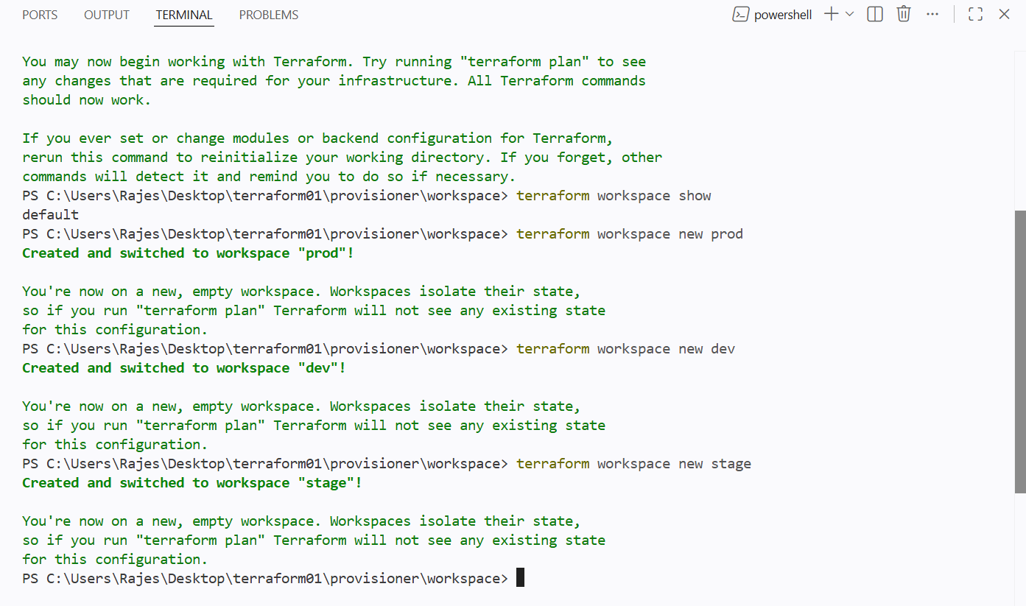

3 new workspaces have been created

Now adding the terraform.workspace block in which I want to use for workspace block

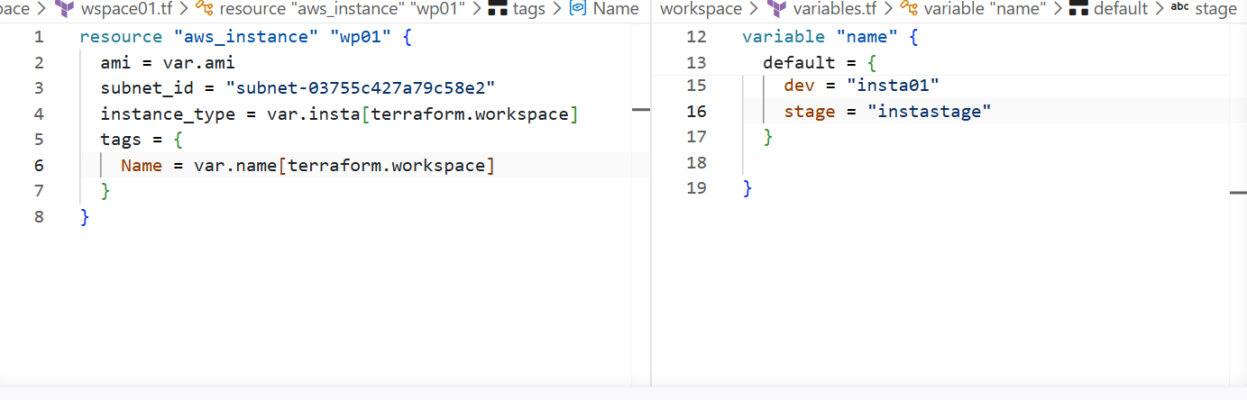

And adding variables for instance_types and instance name for every workspace

In stage branch when I applied it created a new instance

And same will bee for another workspace

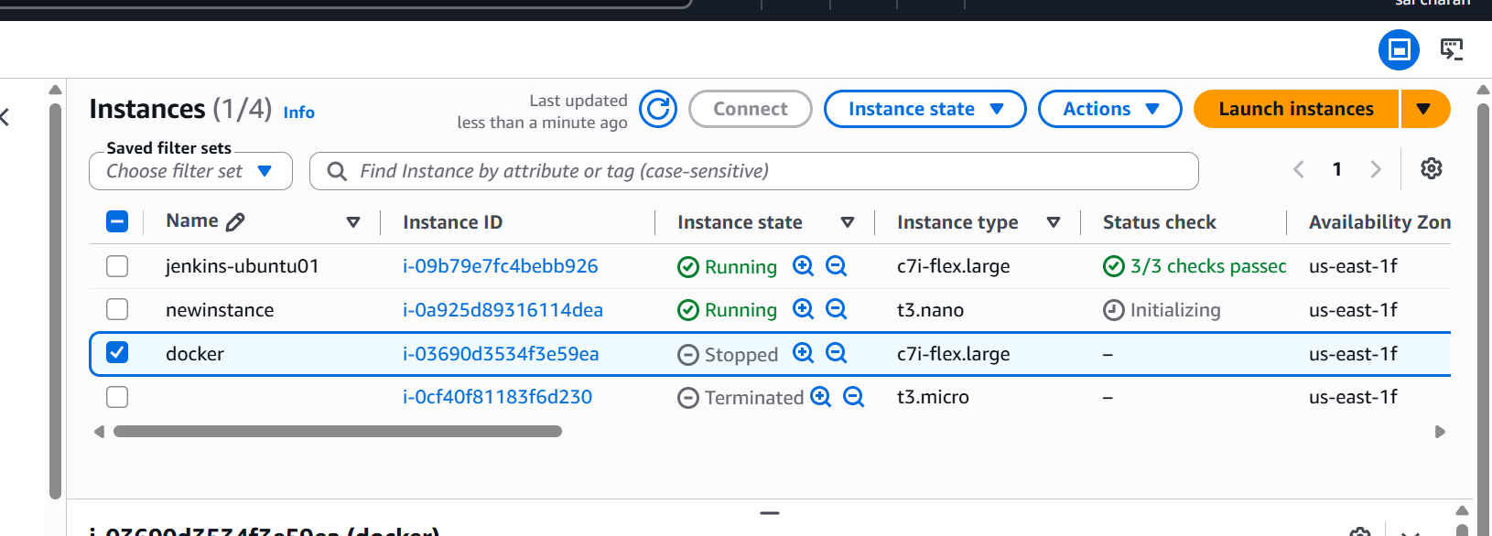

Now switching into another workspace

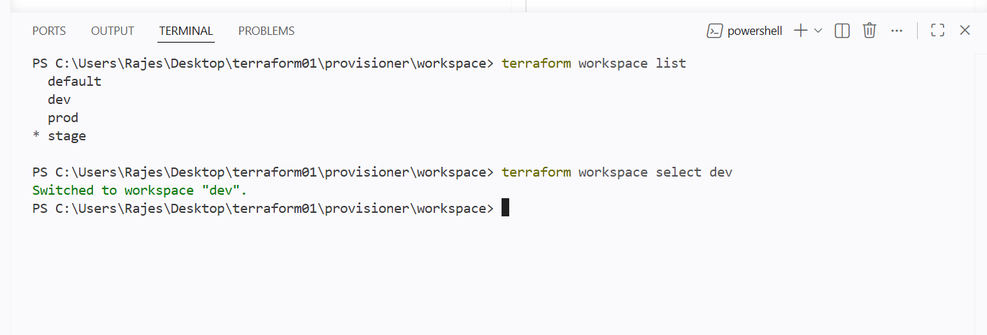

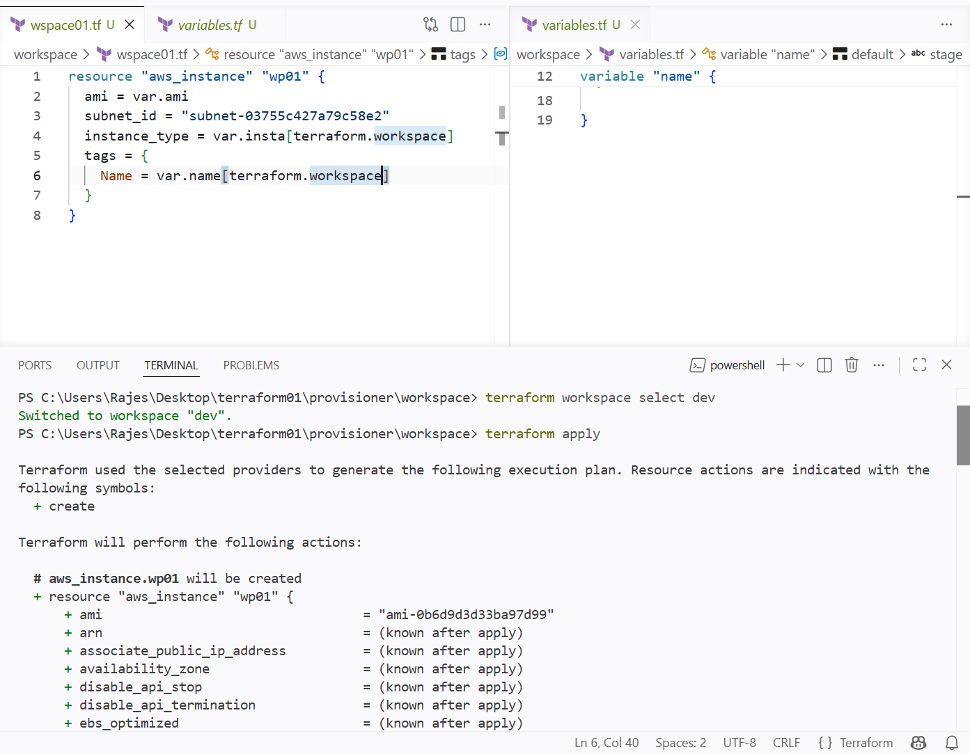

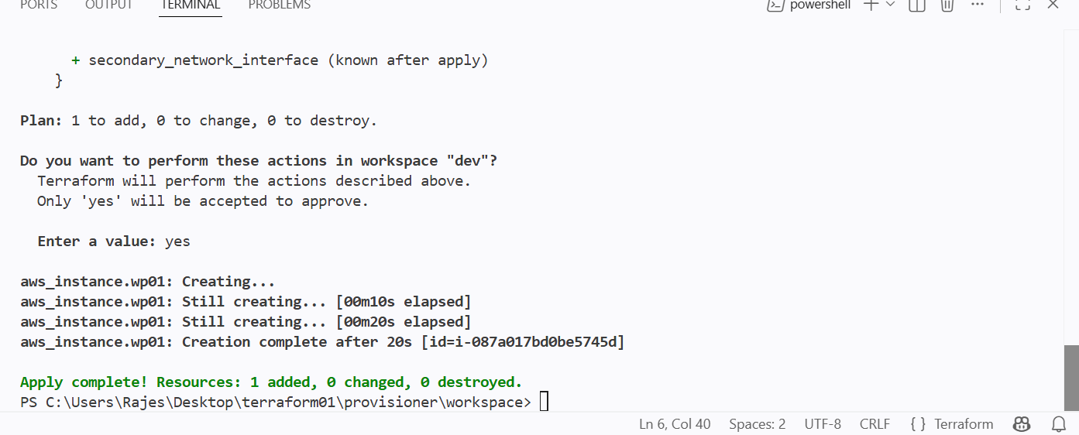

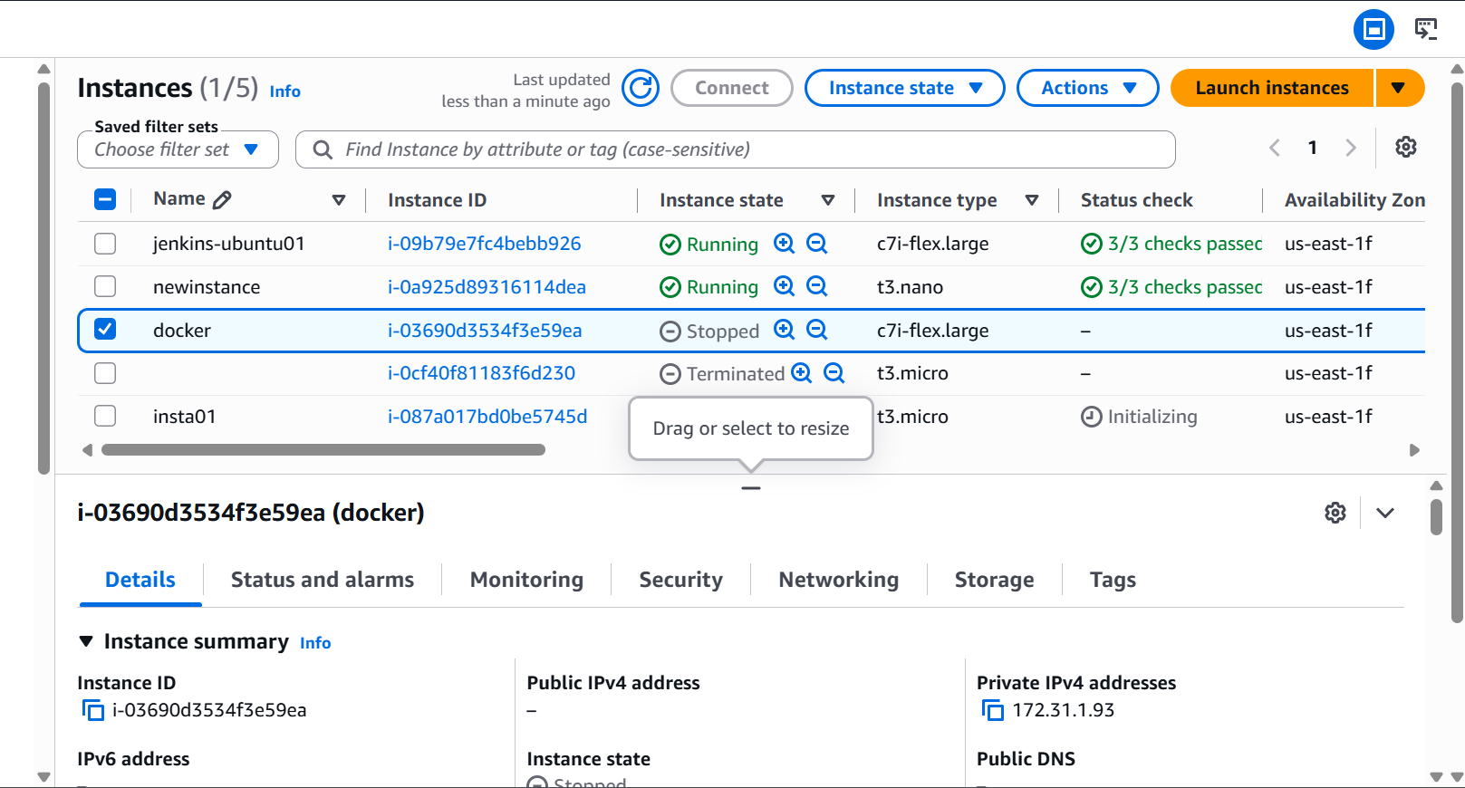

New instance with given name has been created in the ec2 for prod workspace

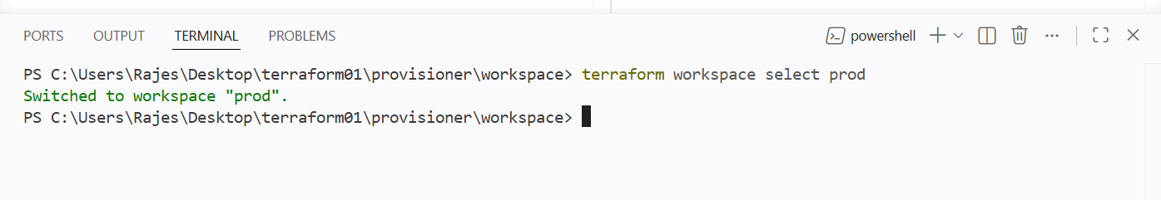

Switching to prod workspace

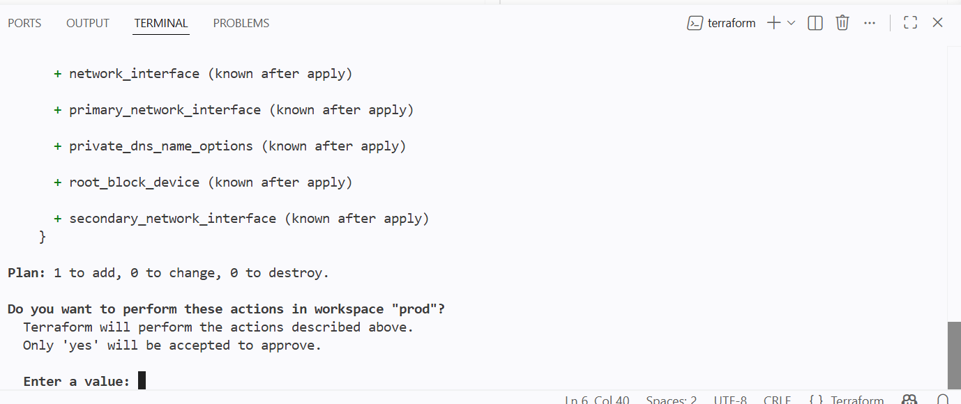

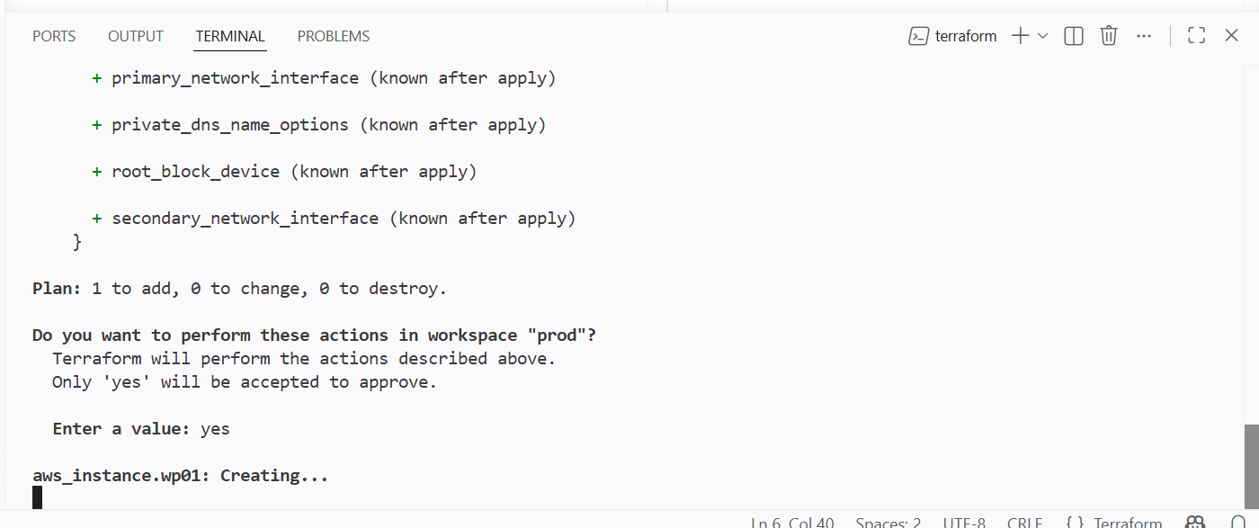

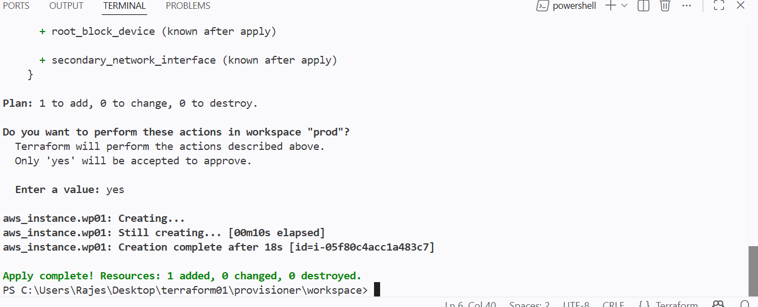

New instance has been created for prod workspace
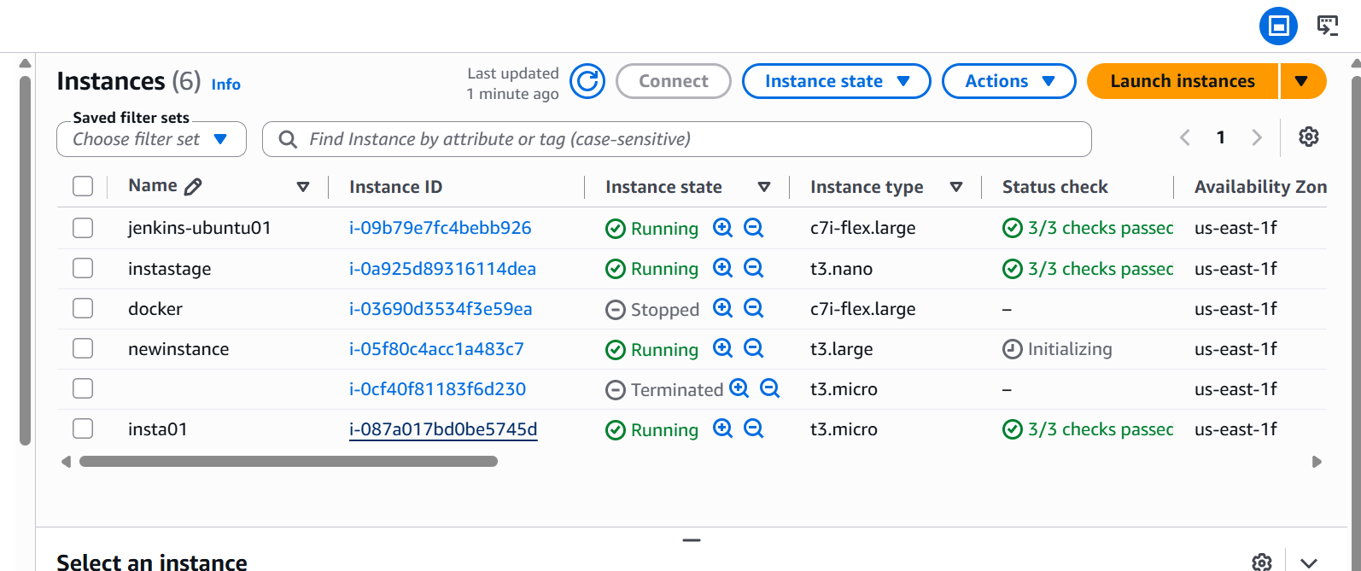

New ec2 instance has been created for prod workspace

